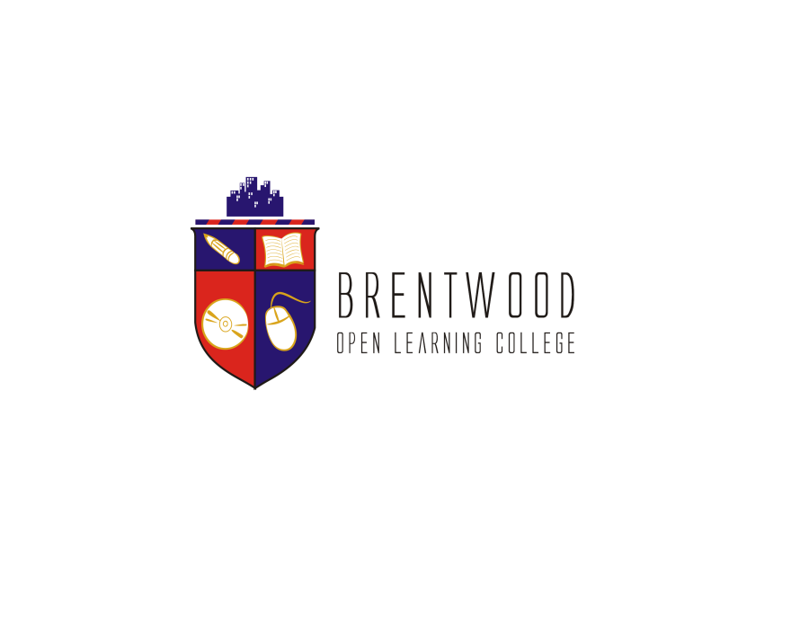
Assignment Cover Sheet

Student Name: | Ayodele Anifowose
Student Number: | 27559
Course: | Advanced Diploma in Construction Management Level 5
Assignment NO: | Human Resource Management

Marking Criteria:
We expect the learners to write minimum one well expressed point in three lines against each allocated mark. This means one needs to write 15 lines with 5 well expressed points to get high grades for a 5 marks question.
For high grades use examples and illustrations where appropriate.
1.i What is Human Resource Management? Discuss its relevance to construction industry?

Human Resource Management (HRM) refers to the strategic approach an organization takes to manage its workforce effectively. It involves a range of activities related to the recruitment, selection, training, development, compensation, and overall well-being of employees to ensure that they contribute positively to the organization's goals and objectives.

With elevance to the Construction Industry: HRM is highly relevant to the construction industry due to the dynamic and labor-intensive nature of construction projects. Here are some reasons why HRM is crucial in this sector:

Skilled Workforce: The construction industry relies heavily on a skilled workforce. HRM ensures that workers have the necessary skills and certifications to perform their jobs effectively.

Safety: Construction sites are inherently hazardous. HRM's focus on safety training and compliance helps reduce accidents and injuries, protecting both workers and the company.

Regulations and Compliance: Construction is subject to numerous regulations and legal requirements. HRM ensures that the company adheres to these regulations, reducing the risk of legal issues.

Labor Shortages: The construction industry often faces labor shortages. Effective HRM can help attract and retain skilled workers, addressing labor challenges.

Project Success: A well-managed workforce is essential for project success. HRM ensures that projects are staffed appropriately with skilled and motivated workers.

Employee Well-being: HRM in construction includes addressing worker well-being, promoting job satisfaction, and addressing mental health issues, which can impact productivity and safety.

In summary, HRM in the construction industry is critical for managing the unique challenges and demands associated with construction projects. It plays a central role in recruiting, training, and retaining skilled workers, ensuring compliance with regulations, and promoting safety and project success. Effective HRM practices can contribute to the overall success and sustainability of construction companies.

ii) What is HRD? How is it different from HRM?

HRD, or Human Resource Development, is a broader concept that encompasses various processes and practices aimed at enhancing the skills, knowledge, abilities, and overall development of an organization's workforce. HRD focuses on enabling employees to acquire and develop the skills and competencies necessary for their current roles and future career growth within the organization. It is a strategic approach to workforce development that aligns individual and organizational goals.

Key distinctions between HRD and HRM (Human Resource Management):

Focus and Scope:

HRM: Human Resource Management primarily deals with the administrative and operational aspects of managing employees within an organization. It encompasses functions such as recruitment, selection, compensation, benefits, performance management, and employee relations. HRM focuses on managing the employment relationship, compliance with labor laws, and day-to-day HR activities.

HRD: Human Resource Development has a broader focus on employee learning, growth, and development. It includes activities related to training, skill development, career planning, talent management, and succession planning. HRD is concerned with improving individual and team capabilities to drive organizational effectiveness and long-term growth.

Goals and Objectives:

HRM: HRM primarily aims to manage and optimize the current workforce to ensure that the organization's immediate HR needs are met. Its objectives include workforce planning, talent acquisition, and ensuring employees are compensated fairly and treated equitably.

HRD: HRD is forward-looking and aims to prepare employees for future challenges and opportunities. Its objectives include enhancing employee skills, fostering a learning culture, and aligning employee development with organizational goals. HRD focuses on the long-term growth and sustainability of the organization.

Activities and Functions:

HRM: HRM activities include recruitment, selection, onboarding, payroll administration, performance evaluations, disciplinary actions, and managing employee benefits and relations.

HRD: HRD activities encompass training and development programs, career development, mentoring, coaching, leadership development, succession planning, and creating a learning environment within the organization.

Time Horizon:

HRM: HRM activities typically have a short- to medium-term focus, addressing immediate HR needs and operational concerns.

HRD: HRD takes a longer-term perspective, focusing on employee growth and development over an extended period to prepare them for future roles and responsibilities.

Relationship with Employees:

HRM: HRM often involves managing employment contracts, enforcing workplace policies, and addressing issues related to compensation, benefits, and employment conditions.

HRD: HRD is more about fostering a positive and supportive learning environment, encouraging employee engagement, and helping individuals reach their full potential within the organization.

HRM and HRD are closely related but distinct areas within human resource management. HRM deals with the administrative and operational aspects of managing employees in the present, while HRD focuses on developing employees' skills and capabilities to prepare them for future challenges and opportunities within the organization. Both functions are critical for the overall success and sustainability of an organization, but they have different goals, activities, and time horizons.

iii) What is reward and compensation policy?

A reward and compensation policy is a foundational document that outlines an organization's approach to compensating its employees for their contributions and work. This policy serves as a strategic guideline that helps organizations make consistent, fair, and transparent decisions regarding employee compensation. It encompasses various aspects of compensation, including base salaries, bonuses, benefits, and other rewards.

The policy typically begins with a clear articulation of the organization's compensation philosophy, which reflects its core principles and beliefs about how employees should be rewarded. This philosophy often emphasizes fairness, equity, competitiveness, and alignment with the organization's values and goals.

The policy also addresses the structure of the organization's compensation system, including pay ranges, pay grades, and job classifications. It defines how jobs are evaluated and placed within the compensation structure. Additionally, it may cover variable compensation components, such as performance-based bonuses or incentives, and how these are determined based on factors like performance metrics and eligibility criteria.

Another critical aspect is compliance with legal requirements and regulations governing compensation practices, ensuring that the organization adheres to labor laws, non-discrimination policies, and other relevant regulations. The policy also communicates how compensation information is shared with employees, fostering transparency and understanding.

A reward and compensation policy is a strategic document that guides an organization's decisions related to how it compensates its employees, fostering fairness, consistency, and alignment with organizational values and objectives. It is a crucial tool for attracting and retaining talent, maintaining legal compliance, and promoting a transparent compensation culture within the organization.

iv) What is the importance of discipline in industry?

Discipline is of paramount importance in the construction industry for several reasons. It plays a crucial role in ensuring the safety, quality, efficiency, and overall success of construction projects. Here are the key reasons why discipline is essential in the construction industry:

Safety: Safety is a top priority in construction. Discipline is vital to enforcing safety protocols and regulations, which are designed to prevent accidents, injuries, and fatalities on construction sites. Failure to adhere to safety rules can lead to dangerous incidents and legal liabilities.

Quality Control: Discipline is necessary for maintaining high-quality standards in construction work. It ensures that employees and contractors follow project specifications, blueprints, and quality control procedures to deliver a finished product that meets or exceeds client expectations.

Efficiency: Construction projects are often time-sensitive and involve complex schedules. Discipline helps workers adhere to project timelines, avoid delays, and maximize productivity. It contributes to efficient resource allocation and project management.

Project Coordination: Construction projects involve numerous trades, subcontractors, and stakeholders. Discipline in communication and coordination ensures that all parties are aligned, reducing the risk of conflicts and delays.

Risk Management: Discipline plays a role in identifying and mitigating risks early in the project. This includes monitoring potential safety hazards, assessing environmental impacts, and proactively addressing issues that could disrupt the project.

Compliance: The construction industry is subject to various regulations, building codes, and zoning laws. Discipline is essential to ensure that all aspects of the project, from permits to environmental regulations, are followed and compliant.

Client Satisfaction: Discipline in adhering to project specifications and delivering on promises enhances client satisfaction. Satisfied clients are more likely to provide repeat business and positive referrals.

Professionalism: The construction industry often involves interaction with clients, inspectors, and the public. Discipline in professionalism, including punctuality, appearance, and communication, contributes to a positive reputation for the company.

Worker Morale: Discipline fosters a positive work environment where rules are consistently enforced and employees feel valued. This can boost morale and job satisfaction among workers.

Environmental Responsibility: Construction projects have environmental impacts. Discipline in adhering to environmental regulations and sustainable practices minimizes negative environmental effects and supports corporate responsibility.

discipline is a cornerstone of success in the construction industry. It encompasses adherence to safety practices, quality control, efficient project management, cost control, compliance with regulations, and professionalism. A disciplined approach helps construction companies deliver projects safely, on time, within budget, and with the expected level of quality, ultimately leading to client satisfaction and the long-term success of the business.

V) What is voluntary and involuntary separation? Discuss with examples.

Voluntary and involuntary separation are two common ways through which employees leave their jobs or employment with an organization. These separations have different causes and implications, and they can occur for various reasons. Here's an explanation of each type with examples:

1. Voluntary Separation:

Definition: Voluntary separation occurs when an employee chooses to resign or leave their job willingly. The decision to leave is made by the employee, often due to personal reasons, career goals, or better opportunities elsewhere.

Examples of Voluntary Separation:

Resignation: An employee decides to resign from their current position to pursue a new job opportunity that aligns better with their career aspirations. For instance, an engineer resigns from one company to join another offering more challenging projects.

Retirement: An employee reaches the eligible age for retirement and chooses to leave the workforce voluntarily. This often involves planning for retirement and may be based on personal financial considerations.

Career Change: An employee decides to switch careers or industries, leading them to leave their current job voluntarily. For example, a marketing professional transitions into teaching.

Relocation: An employee's personal circumstances, such as a spouse's job transfer or family reasons, necessitate a move to a different location, leading to the voluntary separation from their current job.

Entrepreneurship: An employee leaves their job to start their own business or pursue a entrepreneurial venture, driven by a desire for independence and self-employment.

2. Involuntary Separation:

Definition: Involuntary separation occurs when an employee is terminated or laid off from their job without their choice. The decision to end the employment relationship is made by the employer due to various reasons, including performance issues, downsizing, or organizational changes.

Examples of Involuntary Separation:

Layoffs: An organization faces financial challenges or restructuring and decides to reduce its workforce, leading to layoffs. Employees are let go regardless of their individual performance. For instance, a company lays off several employees due to a decline in sales.

Termination for Cause: An employee is terminated due to violations of company policies, misconduct, poor performance, or other justifiable reasons. For example, an employee is terminated for consistently failing to meet sales targets despite warnings.

Position Elimination: An organization restructures or reorganizes its departments, leading to the elimination of certain positions. Employees holding those positions are involuntarily separated. For example, a company consolidates two departments and eliminates redundant positions.

Contract Expiration: In some cases, employees are separated when their fixed-term employment contracts expire, and the organization decides not to renew them.

Mass Closure: In rare situations, entire businesses or branches may be closed, resulting in the involuntary separation of all employees working at those locations.

VI) How is recruitment different from selection?

Recruitment and selection are two distinct stages in the process of acquiring and hiring employees for an organization. While they are closely related, they serve different purposes and involve different activities. Here are the key differences between recruitment and selection:

Recruitment:

Definition: Recruitment is the initial stage of the hiring process. It involves activities aimed at identifying and attracting a pool of potential candidates for job vacancies within the organization.

Objective: The primary objective of recruitment is to create awareness about job openings and encourage qualified individuals to apply for those positions.

Activities:

Job Posting: Creating job advertisements and posting them on various platforms, such as job boards, company websites, and social media.
Talent Sourcing: Actively searching for potential candidates through methods like networking, employee referrals, and outreach to passive job seekers.
Building a Candidate Pool: Collecting resumes, applications, and expressions of interest from interested candidates.
Initial Screening: Basic assessment of candidates to determine if they meet minimum qualifications and job requirements.
Focus: Recruitment focuses on generating interest and applications from a wide range of candidates, including both qualified and unqualified individuals.

Timing: Recruitment is an ongoing process and can happen continuously, even when there are no immediate job openings. It helps organizations maintain a talent pipeline.

Selection:

Definition: Selection is the subsequent stage of the hiring process that involves assessing, evaluating, and choosing the most suitable candidates from the pool of applicants generated during recruitment.

Objective: The primary objective of selection is to identify the best-fit candidates who possess the required skills, qualifications, and attributes for the specific job vacancy.

Activities:

Resume Review: A thorough evaluation of resumes and applications to shortlist candidates who meet the job requirements.
Interviews: Conducting interviews, which can be in-person, phone, or video interviews, to assess candidates' qualifications, skills, and cultural fit.
Assessments: Administering tests, assessments, or practical exercises to evaluate candidates' abilities and competencies.
Reference Checks: Contacting references provided by candidates to verify their work history and qualifications.
Final Selection: Making the ultimate hiring decision based on the collected information and evaluations.
Focus: Selection focuses on evaluating candidates' suitability for a specific job, considering factors like skills, experience, cultural fit, and alignment with the organization's values and goals.

Timing: Selection typically occurs after the recruitment phase, once a job vacancy needs to be filled.

Recruitment is about generating interest and attracting a pool of potential candidates, while selection is about evaluating and choosing the best-fit candidates from that pool for a specific job vacancy. Both recruitment and selection are essential steps in the overall hiring process, and their effectiveness can significantly impact the quality of talent an organization brings on board.

2) Discuss various techniques of manpower planning.

Manpower planning, also known as workforce planning, is a critical process that involves determining an organization's current and future staffing needs, and developing strategies to meet those needs efficiently. Various techniques and methods can be used for manpower planning, depending on the organization's size, industry, and specific requirements. Here are some common techniques of manpower planning:

- Demand Forecasting:

Trend Analysis: Examining historical data and trends in workforce size, turnover rates, and business operations to project future staffing needs.
Workload Analysis: Assessing the volume and nature of work, including projects, tasks, and job roles, to estimate the workforce required to meet the demand.
- Supply Analysis:

Internal Assessment: Evaluating the current workforce's skills, capabilities, and performance to identify potential internal candidates for future roles.
External Assessment: Analyzing the external labor market to understand the availability of talent with the required skills and qualifications.
- Gap Analysis:

Skills Gap Analysis: Identifying the gap between the skills and competencies required for future roles and the skills possessed by current employees.
Quantity Gap Analysis: Determining the difference between the current workforce size and the required workforce size to meet projected demand.
- Succession Planning:

Identifying High-Potential Employees: Recognizing and developing employees with the potential to fill critical leadership and key positions in the organization.
Developing Talent Pipelines: Creating a talent pipeline for succession, ensuring that there are qualified candidates ready to step into key roles as needed.
- Scenario Planning:

Creating Scenarios: Developing alternative future scenarios based on different assumptions, such as economic conditions, industry changes, or technology advancements, and assessing their workforce implications.
Contingency Planning: Developing plans and strategies to address workforce needs in response to various scenarios.
- Workforce Analytics:

Data Analytics: Utilizing data and analytics tools to gather insights into workforce trends, employee performance, turnover rates, and other relevant metrics.
Predictive Analytics: Using statistical models to forecast future staffing needs and identify potential risks and opportunities.
- Skills Inventories:

Employee Skills Database: Maintaining a database of employees' skills, certifications, and qualifications to match them with future job requirements.
Skills Assessments: Conducting skills assessments and surveys to understand the skill sets available within the organization.
- Consultation and Collaboration:

Internal Collaboration: Involving various departments and stakeholders, including HR, finance, and department heads, to align workforce planning with overall business goals.
External Consultation: Seeking input and guidance from external consultants, industry experts, or labor market specialists to gain insights into future workforce trends.

Effective manpower planning involves a combination of these techniques and methods, customized to the organization's unique needs and goals. It is an ongoing process that requires regular evaluation and adjustment as business conditions change.

Student Statement:

By submitting this assignment, I confirm that this is my own work.

Student Signature | Ayodele Anifowose | Date | 08/10/23

For Tutor / Assessor Use Only
Total Marks
Marks Obtained
Percentage / Grade

